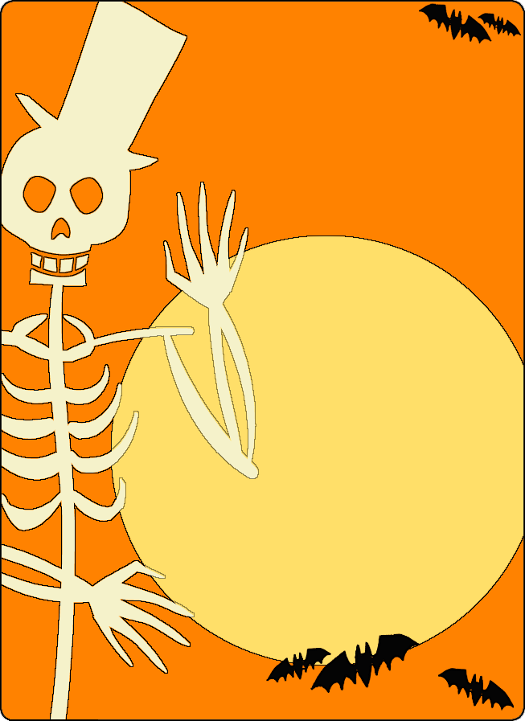
Halloween Party

October [day] at [time]

[Street Address]

[City]
Please join us for some ghoulish games, freaky fun, and frightening food!
Bring a flashlight for a spooky game of tag
Parents are welcome to stay for special Halloween beverages
RSVP [Name] at [phone]

