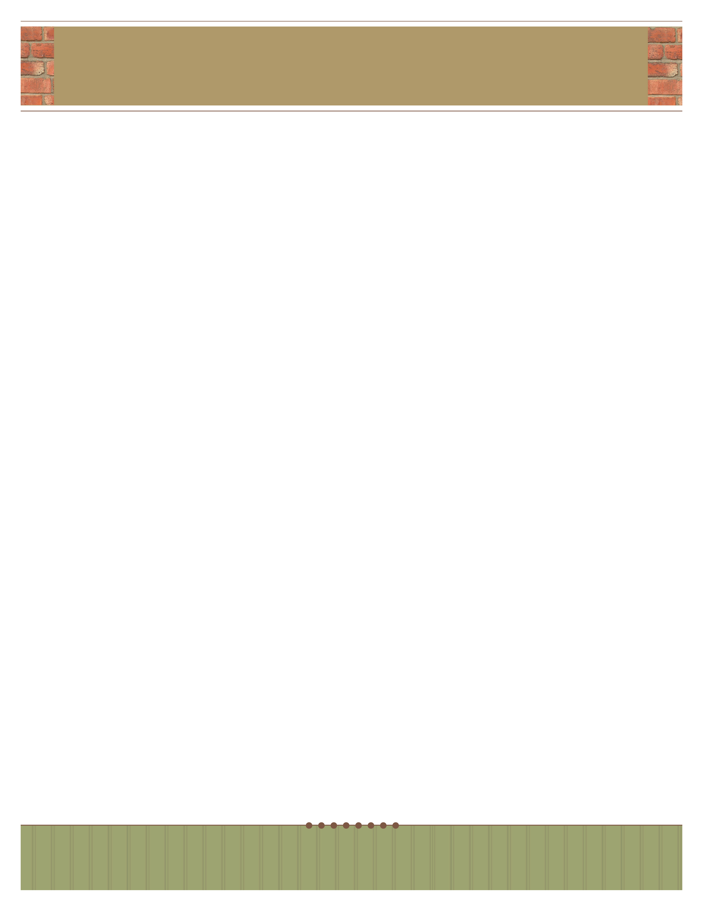

**your name here**

your title here

## telephone: 555.555.5555 | facsimile: 555.555.5555 | email: yourmail@email.com

address: 5555 Street Address | City, State 55555

website**:** www.webaddress.com

Begin your letter here.