

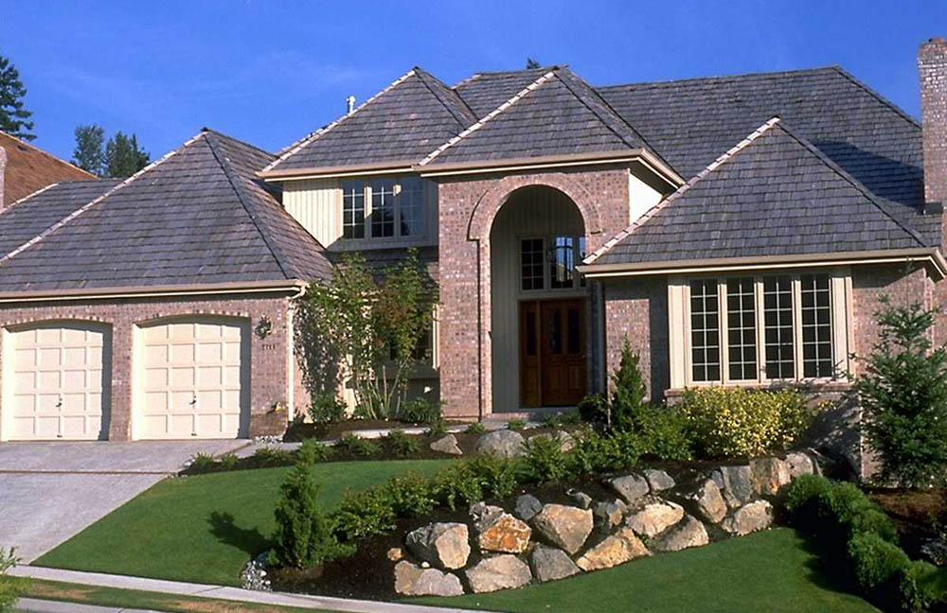
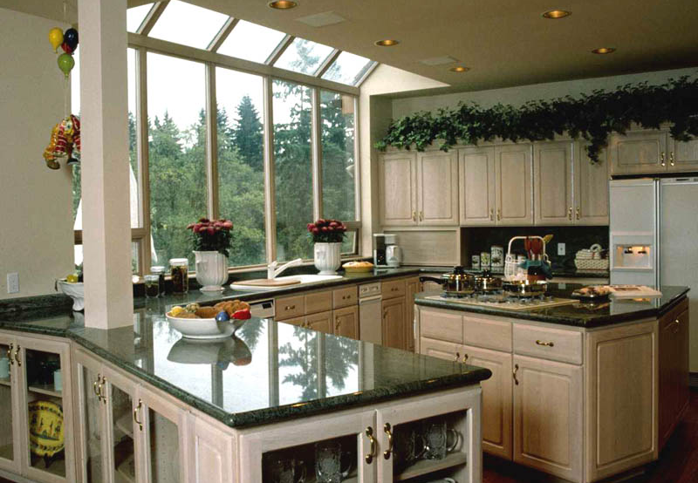
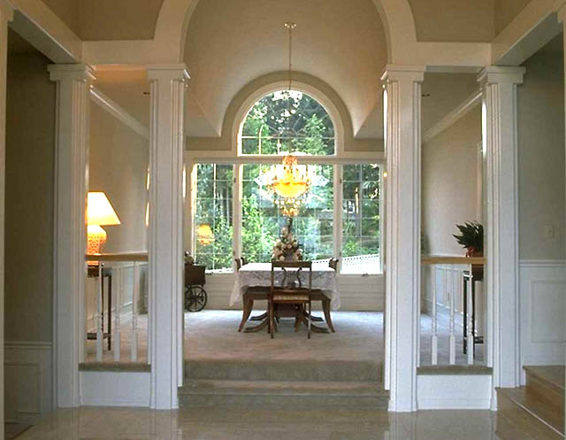

Bound to sell quickly at $329,995
LOGO
(000) 555-1212 direct
(000) 555-1212 cell
email@youremail.com
www.yourwebsite.com

Agent Name

For a personal showing, please call 800-555-1212
or experience
a virtual tour
on our website: www.yourwebsite.com

10224 SW River Lane • Portland, OR 97231
Fabulous space, great location, you must see it to really appreciate the ambiance and setting. Designed for family living with dramatic open areas and plenty of windows and light. Lushly landscaped with Koi pond and perennial gardens. Only 20 minutes from city center and two blocks from Kennedy Elementary School.

- 3200 square feet, 4 bedrooms, 3.5 bathrooms
- Large, finished basement, perfect for family activities
- Hardwood floors with mahogany inlay
- Custom gourmet kitchen with Sub-Zero refrigerator & double ovens

