
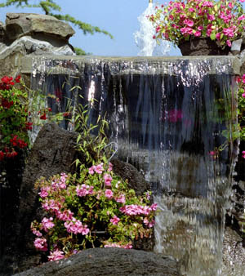
For Sale By Owner

10224 SW River Lane • Portland, OR 97231
To place your photos in customized shapes; first, ungroup photos, click on existing photo, go to “format”, “backgrounds and shading”, “fill – color,” down to “fill effects.” From the fill effects menu bar, “select picture.” Find your picture and select “insert” then “OK.” Customize and replace all photos as needed. Replace these instructions with a description of your home, location, proximity to schools, etc.
$348,000

- 3200 square feet, 4 bedrooms, 3.5 bathrooms
- Large, finished basement
- Hardwood floors with mahogany inlay
- Custom gourmet kitchen with Sub-Zero refrigerator & double ovens
- Formal dining area
- Custom designed home office space

BY APPOINTMENT ONLY

Call Jim or Sue, evenings at
800-555-1212

