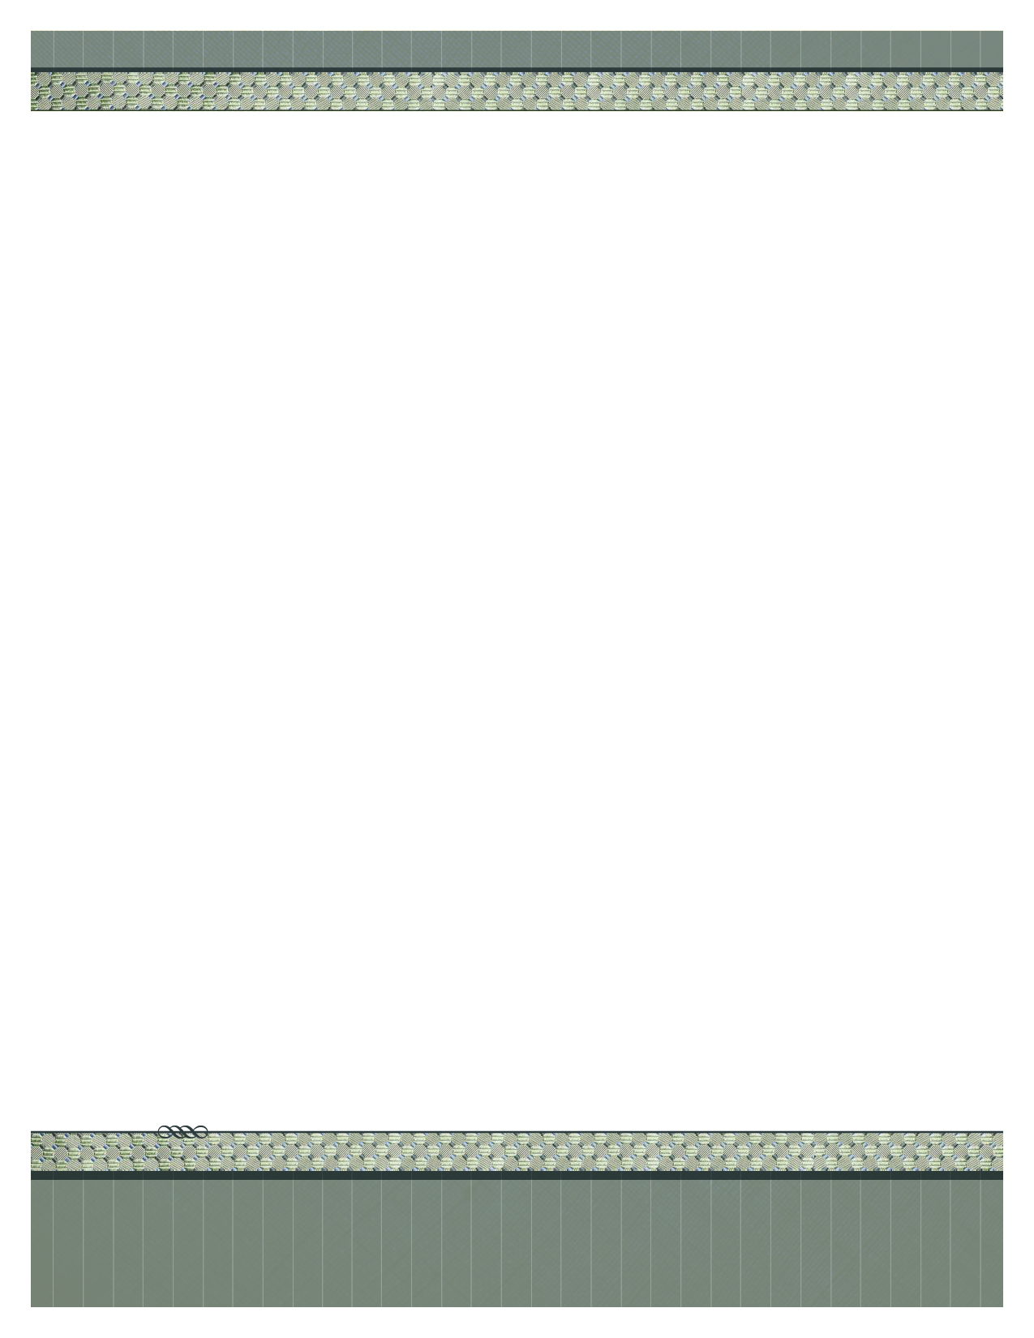­­

2012 Street address suite 310

City and, STATE 97555

555.555.5555 office • 555.555.5555 fax

www.your-url-goes-here.com

Begin your letter here.

Place logo

or logotype here,

otherwise

delete this.

Insert Your Name Here